1. Apply for SMFI College Scholarship
   1. Application Form
      1. Personal Background
         1. Last Name, First Name, Middle Name
         2. City Address
         3. Telephone Numbers (assumes ownership of a landline)
         4. Email Address (assumes access to an internet café/shop)
         5. Cellphone Number (assumes ownership of mobile phone)
         6. Date of Birth (NSO certified birth certificate)
         7. Age (is there an ideal age threshold, minimum/maximum age requirement)
         8. Status (shouldn’t scholars be single/unmarried individuals)
         9. Sex (is there an ideal ratio of male and female scholars)
         10. Place of Birth (NSO certified birth certificate)
         11. Nationality (NSO certified birth certificate)
         12. Height (is this even relevant/should be verified)
         13. Weight (is this even relevant/should be verified)
         14. Religion (provide a top 5/top 10 list)
      2. Academic Background
         1. Name of Public High School graduating from
         2. Section (is this even relevant)
         3. Complete Address of School
         4. Name of Principal
         5. Telephone Numbers
         6. Membership in Organizations in and outside of school (current year)
      3. College Plan
         1. School you plan to enrol in (1st and 2nd choices)
         2. Course you plan to take (1st and 2nd choices)
      4. Family Background
         1. Father – Name/Occupation/Name of Company/Telephone/Mobile Phone Number/Date of Birth (mm/dd/yy)
         2. Mother – Name/Occupation/Name of Company/Telephone/Mobile Phone Number/Date of Birth (mm/dd/yy)
         3. Guardian – Name/Occupation/Name of Company/Telephone/Mobile Phone Number/Date of Birth (mm/dd/yy)
         4. Brothers and Sisters – Age/School/Grade/Year (level)/Employed (yes/no)/Married (yes/no)
      5. Aggregate Income of Family Members in the Same Household for One Year
         1. Amount in words
         2. Amount in figures
   2. Certified List of Individual Incomes and their Sources
   3. Photocopy of F-138 or 4th year High School Report Card with the Second or Third Grading Period’s average
   4. Photocopy of Income Tax Return of your parents and family members in the same household as presented above
   5. Certificate of Non-filing of Income from the BIR if exempt from filing Income Tax Return
2. Screen grades of the applicant (insert here the business rule)
3. If qualified, schedule examination for the applicant either through telephone/mobile phone call and/or text message
4. Having passed the examination, schedule interview for the applicant either through telephone/mobile phone call and/or text message
   1. Applicants will be rated according to the following categories:
      1. Academic Preparation (25 points)
         1. Additional points for class standing of the student
      2. Personality (20 points)
      3. Maturity and Attitude (20 points)
      4. Ambition (20 points)
      5. X-factor (15 points)
   2. Scholars who will take the exam must obtain an 80.0% and above rating during the interview (How does this exactly work?)
5. Having hurdled the examination and interview, carry out verification of background information (provided in the application form)
   1. Sketch of the scholar’s house to the nearest SM mall
      1. Last Name, First Name, Middle Name
      2. Telephone Numbers
      3. Mobile Phone Numbers
      4. Date
      5. Complete Home Address
      6. Name of Public High School graduating from
      7. Description of the scholar’s house (in 3 sentences)
      8. Home Visit Checklist
         1. Name
         2. Address
         3. Own Residence:
            1. Mostly Made of Wood & GI Materials
            2. Mostly Made of Concrete Materials
         4. Rent:
            1. below 2,000
            2. 2,000 & up
         5. Informal Dweller
         6. Furnishing
            1. Sala Set (sofa, side chairs & tables)
            2. Television
            3. Radio
            4. Electric Fan/Aircon
            5. Telephone/Cellphone
            6. Computer
            7. Stove
            8. Dining Set (dining tables & chairs)
            9. Refrigerator
            10. Toilet & Bath
         7. House Payments
            1. Electricity
            2. Water
            3. Telephone/Cellphone
            4. Cable
            5. Aircon
            6. Educational Plan
         8. Household Members:
            1. 1-5 members
            2. 6-10 members
            3. 11-above members
         9. Income Earners in the Family
            1. None
            2. One
            3. Two
            4. Three or More
         10. Character Reference
             1. Known to Brgy. Chairman/Officials
             2. Known to Neighbors
         11. Names of person(s) accomplishing the Home Visit Checklist
         12. Date of accomplishment of Home Visit Checklist
         13. For SM Foundation Inc Use
             1. # of Points
             2. Accepted
             3. Disqualified
             4. Approved by
             5. Date
             6. Notes
6. Upon confirmation of background information, conduct ranking of applicants since there are only a limited number of slots for the College Scholarship Program
7. Award scholarship contracts to top ranked applicants
   1. Checklist for SMFI Scholar Contract Signing
      1. Application Form
      2. 2 pieces 2x2 coloured picture
      3. ITR/Affidavit & Certification
      4. Background Investigation Form
      5. HS Grade or Card
      6. Home Sketch
      7. Exam Result from Universities
      8. Community Tax Certificate (CTC) of Parent or Guardian
      9. Community Tax Certificate (CTC) of Student
      10. 3 Copies of Scholarship Contract
      11. BDO (Cash Card) Enrolment Form
      12. Case Summary
      13. Date of Contract Signing
      14. Name and Signature of the person accomplishing the checklist
8. Applicants enrol in their preferred course and school – based on Enrolment Certificate from the SM Foundation (Manila) or from Scholarship Coordinator (provincial)
9. Scholars submit photocopy of all documents received from the school to SM Foundation within 1 week of enrolment
   1. Registration Form
   2. Assessment Form,
   3. Certificate of Registration
   4. Curriculum (Also submitted here?)
10. SM Foundation pays for the scholars’ matriculation fees based on the submitted billing statement/assessment record
    1. Registration and Assessment Forms should always reflect the breakdown of fees and class schedules

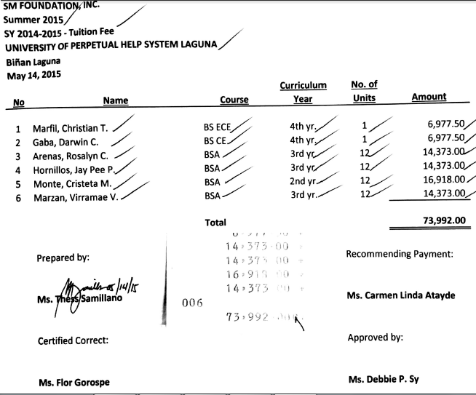

1. Prior to issuance of certificate of scholarship in succeeding terms, SM Foundation checks on the grades of scholars to ensure that these fall within guidelines.
   1. Scholars submit summary of grades and photocopy of class cards to SM Foundation
      1. Summer Classes
         1. SM Foundation will only shoulder Official Summer Classes
         2. Submit a letter of request for summer classes. Provide an explanation if the subjects to be taken are different from those reflected in the curriculum
         3. Enrol in Official Summer Classes using SM Foundation Enrolment Certificate
      2. Advance Subjects
         1. SM Foundation will only cover the cost of the units of the subjects
         2. Miscellaneous and other expenses will be shouldered by the scholar
      3. Grades with Deficiency
         1. Photocopies class cards and makes a summary of GWA (computed as Grade multiplied by Number of units)
         2. Submits a letter (in English) addressed to the Executive Director for Education, SM Foundation Inc
            1. Explains the reason for failed subjects or for not attaining the required GWA of 2.5 or 85
            2. Explains the effect of the deficiency. Will this affect the length of time for the scholar to graduate?
            3. When will the scholar retake the subject?
            4. Explains how the scholar will correct the deficiency
            5. Attaches the applicable curriculum to the letter.
      4. Summary of Grades
         1. Photocopies class cards or prints out a summary of grades from school website
         2. Submits a summary of grades following the prescribed format:

